Arquitectura de Software.

Nombre del profesor: Alfonso Miguel Reyes.

Nombre del Alumno: Perales Chávez Alan.

Grupo: “B”.

Semestre: 4° semestre.

CDMX, a 27 de febrero del 2021.

**<?xml version = "1.0"?>**

**2 <!DOCTYPE html PUBLIC "-//W3C//DTD XHTML 1.0 Strict//EN"**

**3 "http://www.w3.org/TR/xhtml1/DTD/xhtml1-strict.dtd">**

**4**

**5 <!-- Fig. 25.1: clock.jsp -->**

**6**

**7 <html xmlns = "http://www.w3.org/1999/xhtml">**

**8**

**9 <head>**

**10 <meta http-equiv = "refresh" content = "60" />**

**11**

**12 <title>A Simple JSP Example</title>**

**13**

**14 <style type = "text/css">**

**15 .big { font-family: helvetica, arial, sans-serif;**

**16 font-weight: bold;**

**17 font-size: 2em; }**

**18 </style>**

**19 </head>**

**20**

**21 <body>**

**22 <p class = "big">Simple JSP Example</p>**

**24 <table style = "border: 6px outset;">**

**25 <tr>**

**26 <td style = "background-color: black;">**

**27 <p class = "big" style = "color: cyan;">**

**28**

**29 <!-- JSP expression to insert date/time -->**

**30 <%= new java.util.Date() %>**

**31**

**32 </p>**

**33 </td>**

**34 </tr>**

**35 </table>**

**36 </body>**

**37**

**38 </html>**

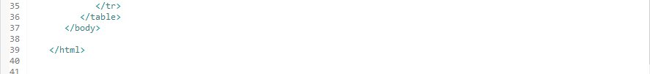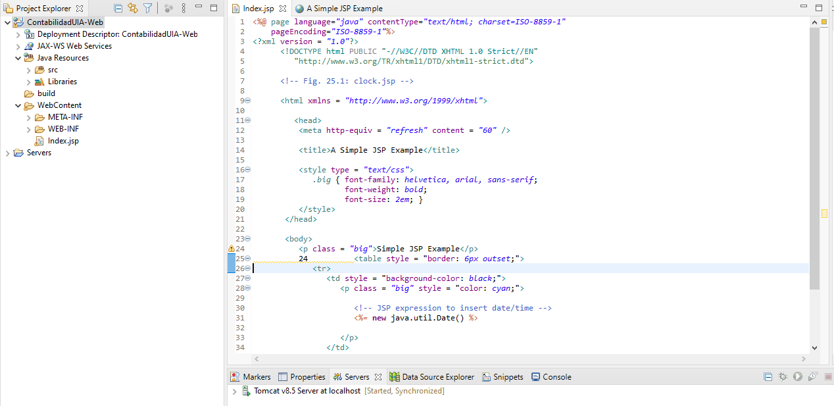

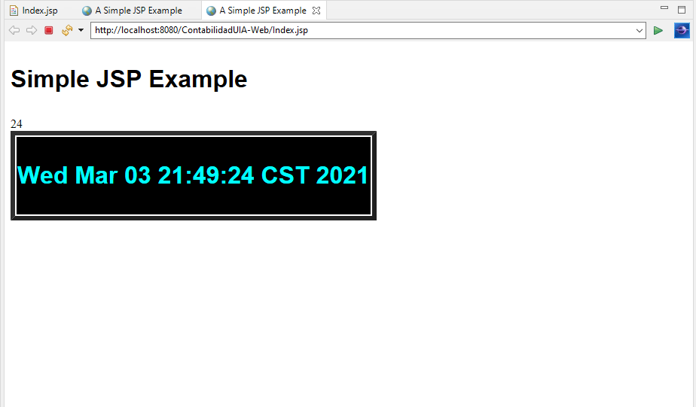

SEGUNDO.

**1 <?xml version = "1.0"?>**

**2 <!DOCTYPE html PUBLIC "-//W3C//DTD XHTML 1.0 Strict//EN"**

**3 "http://www.w3.org/TR/xhtml1/DTD/xhtml1-strict.dtd">**

**4**

**5 <!-- Fig. 25.4: welcome.jsp -->**

**6 <!-- JSP that processes a "get" request containing data. -->**

**7**

**8 <html xmlns = "http://www.w3.org/1999/xhtml">**

**9**

**10 <!-- head section of document -->**

**11 <head>**

**12 <title>Processing "get" requests with data</title>**

**13 </head>**

**14**

**15 <!-- body section of document -->**

**16 <body>**

**17 <% // begin scriptlet**

**18**

**19 String name = request.getParameter( "firstName" );**

**20**

**21 if ( name != null ) {**

**22**

**23 %> <%-- end scriptlet to insert fixed template data --%**

**25 <h1>**

**26 Hello <%= name %>, <br />**

**27 Welcome to JavaServer Pages!**

**28 </h1>**

**29**

**30 <% // continue scriptlet**

**31**

**32 } // end if**

**33 else {**

**34**

**35 %> <%-- end scriptlet to insert fixed template data --%>**

**36**

**37 <form action = "welcome.jsp" method = "get">**

**38 <p>Type your first name and press Submit</p>**

**39**

**40 <p><input type = "text" name = "firstName" />**

**41 <input type = "submit" value = "Submit" />**

**42 </p>**

**43 </form>**

**44**

**45 <% // continue scriptlet**

**46**

**47 } // end else**

**48**

**49 %> <%-- end scriptlet --%>**

**50 </body>**

**51**

**52 </html> <!-- end XHTML document -->**

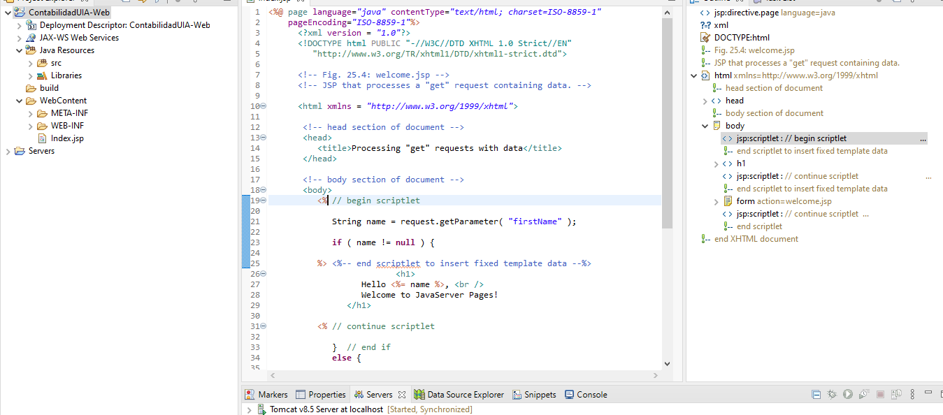

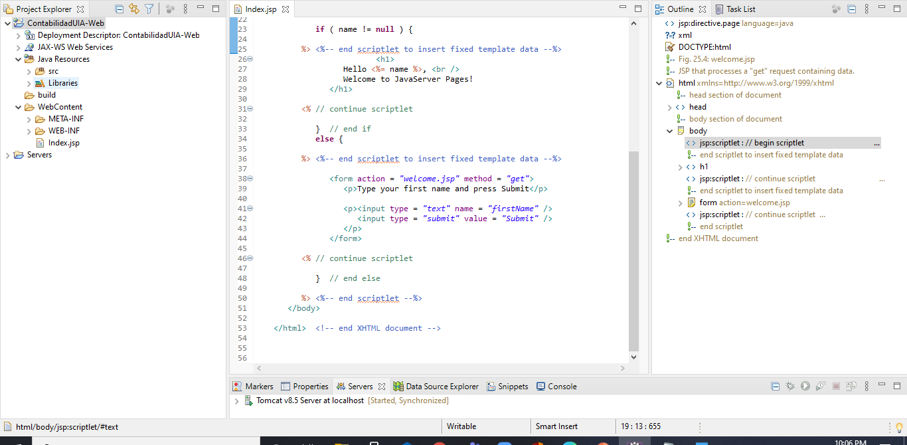

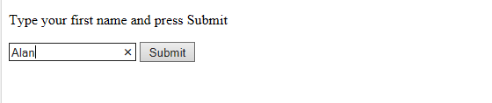

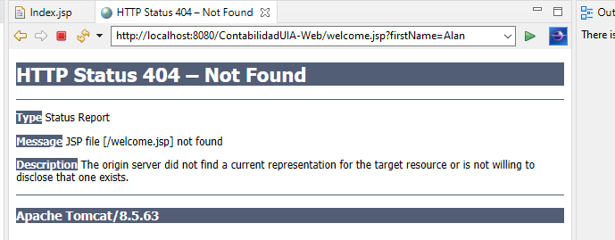

Tercero.

**1 <!-- Fig. 25.7: banner.html -->**

**2 <!-- banner to include in another document -->**

**3 <div style = "width: 580px">**

**4 <p>**

**5 Java(TM), C, C++, Visual Basic(R),**

**6 Object Technology, and <br /> Internet and**

**7 World Wide Web Programming Training&nbsp;<br />**

**8 On-Site Seminars Delivered Worldwide**

**9 </p>**

**10**

**11 <p>**

**12 <a href = "mailto:deitel@deitel.com">deitel@deitel.com</a>**

**13 <br />978.461.5880<br />12 Clock Tower Place, Suite 200,**

**14 Maynard, MA 01754**

**15 </p>**

**16 </div>**

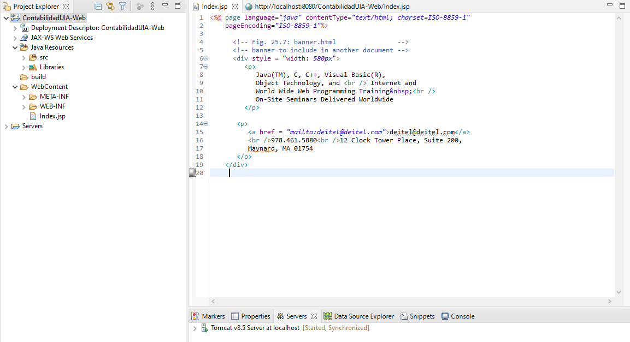

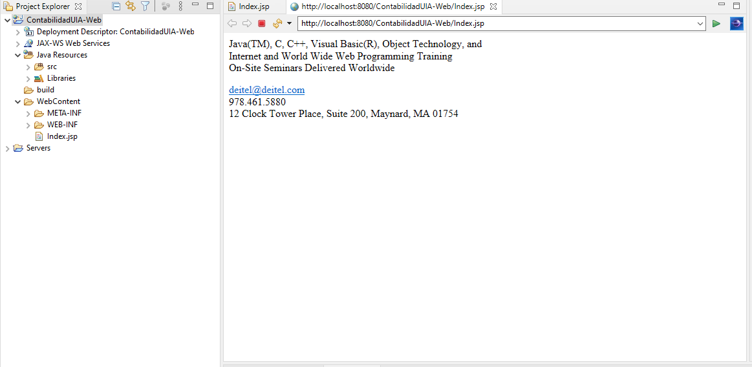

**Cuatro**

**1 <!-- Fig. 25.8: toc.html -->**

**2 <!-- contents to include in another document -->**

**3**

**4 <p><a href = "http://www.deitel.com/books/index.html">**

**5 Publications/BookStore**

**6 </a></p>**

**7**

**8 <p><a href = "http://www.deitel.com/whatsnew.html">**

**9 What's New**

**10 </a></p>**

**11**

**12 <p><a href = "http://www.deitel.com/books/downloads.html">**

**13 Downloads/Resources**

**14 </a></p>**

**15**

**16 <p><a href = "http://www.deitel.com/faq/index.html">**

**17 FAQ (Frequently Asked Questions)**

**18 </a></p>**

**19**

**20 <p><a href = "http://www.deitel.com/intro.html">**

**21 Who we are**

**22 </a></p>**

**23**

**24 <p><a href = "http://www.deitel.com/index.html">**

**25 Home Page**

**26 </a></p>**

**27**

**28 <p>Send questions or comments about this site to**

**29 <a href = "mailto:deitel@deitel.com">**

**30 deitel@deitel.com**

**31 </a><br />**

**32 Copyright 1995-2003 by Deitel &amp; Associates, Inc.**

**33 All Rights Reserved.**

**34 </p>**

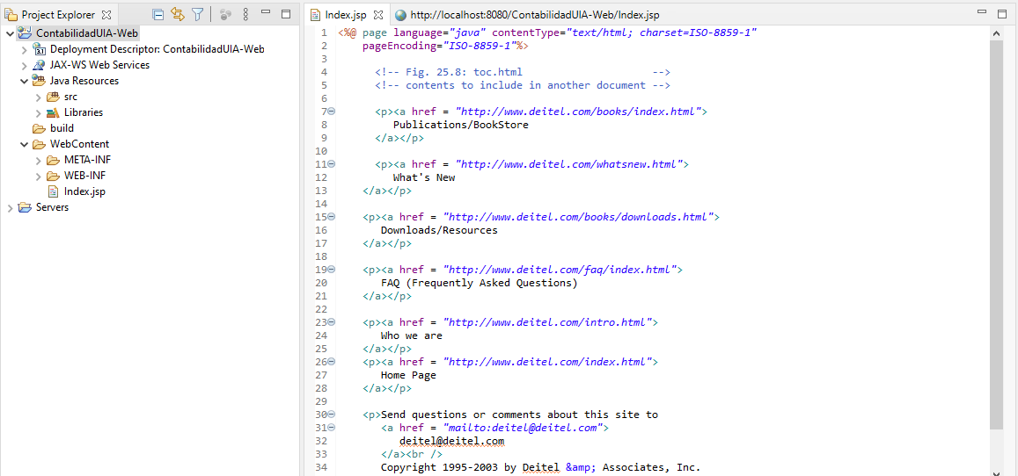

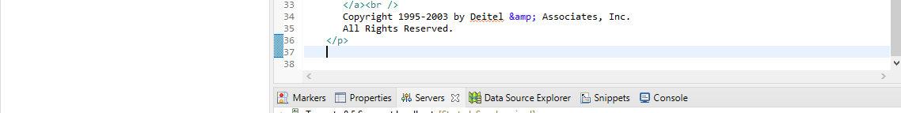

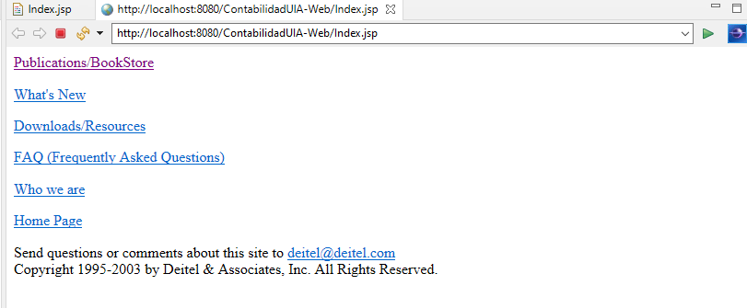

**CINCO**

**1 <!-- Fig. 25.9: clock2.jsp -->**

**2 <!-- date and time to include in another document -->**

**3**

**4 <table>**

**5 <tr>**

**6 <td style = "background-color: black;">**

**7 <p class = "big" style = "color: cyan; font-size: 3em;**

**8 font-weight: bold;">**

**9**

**10 <%-- script to determine client local and --%>**

**11 <%-- format date accordingly --%>**

**12 <%**

**13 // get client locale**

**14 java.util.Locale locale = request.getLocale();**

**15**

**16 // get DateFormat for client's Locale**

**17 java.text.DateFormat dateFormat =**

**18 java.text.DateFormat.getDateTimeInstance(**

**19 java.text.DateFormat.LONG,**

**20 java.text.DateFormat.LONG, locale );**

**21**

**22 %> <%-- end script --%>**

**23**

**24 <%-- output date --%>**

**25 <%= dateFormat.format( new java.util.Date() ) %>**

**26 </p>**

**27 </td>**

**28 </tr>**

**29 </table>**

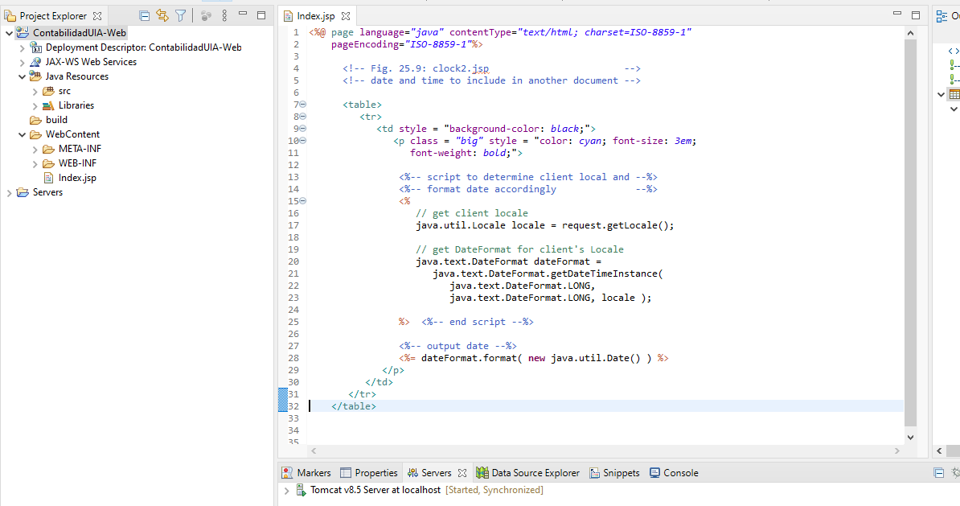

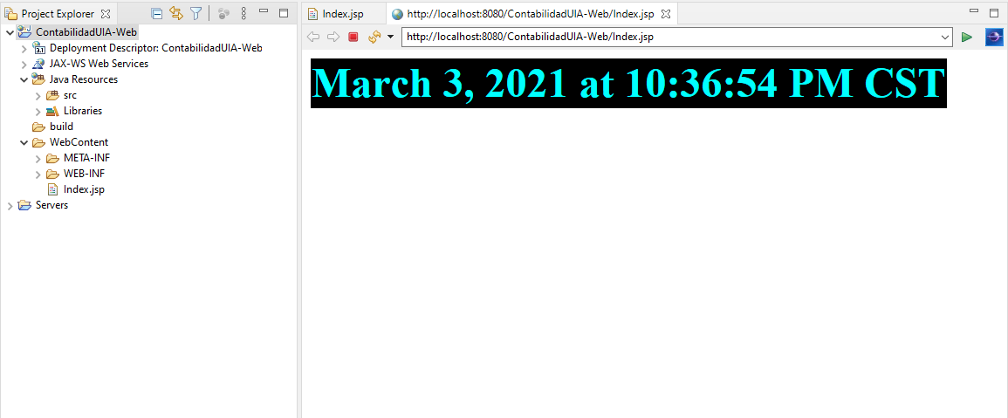

**SEIS**

<?xml version = *"1.0"*?>

<!DOCTYPE html PUBLIC "-//W3C//DTD XHTML 1.0 Strict//EN"

"http://www.w3.org/TR/xhtml1/DTD/xhtml1-strict.dtd">

<!-- Fig. 25.11: forward1.jsp -->

<html xmlns = *"http://www.w3.org/1999/xhtml"*>

<head>

<title>Forward request to another JSP</title>

</head>

<body>

<% // begin scriptlet

String name = request.getParameter( "firstName" );

**if** ( name != **null** ) {

%> <%-- end scriptlet to insert fixed template data --%>

<jsp:forward page = *"forward2.jsp"*>

<jsp:param name = *"date"*

value = *"*<%= **new** java.util.Date() %>*"* />

</jsp:forward>

<% // continue scriptlet

} // end if

**else** {

%> <%-- end scriptlet to insert fixed template data --%>

<form action = *"forward1.jsp"* method = *"get"*>

<p>Type your first name and press Submit</p>

<p><input type = *"text"* name = *"firstName"* />

<input type = *"submit"* value = *"Submit"* />

</p>

</form>

<% // continue scriptlet

} // end else

%> <%-- end scriptlet --%>

</body>

</html> <!-- end XHTML document -->

